**HTML Emojis**

Last Updated : 22 Jul, 2024

**HTML emojis**are graphical representations of emotions, objects, symbols, etc., displayed using Unicode characters or emoji entities within HTML documents. They enrich communication, adding visual context to web pages, emails, and messaging platforms.

The <meta charset=”UTF-8″> element defines the character set. Unreachable UTF-8 characters displayed with entity numbers starting with &# and ending with **;** .

**Syntax:**

<!DOCTYPE html>  
<html lang="en">  
  
<head>  
 <title>UTF-8 Character Example</title>  
</head>  
  
<body>  
 <p>&#number;</p>  
 <!-- Replace 'number' with the corresponding UTF-8 character code -->  
 <p>&#9731;</p>   
 <!-- Example: Unicode for a snowflake symbol -->  
</body>  
  
</html>

Emojis are also characters from the UTF-8 alphabet and can be used in HTML by mentioning the corresponding emoji, decimal (dec) or hexadecimal (hex) reference in the above syntax.

**HTML Emojis Examples**

**1. HTML Emojis using Unicode Decimal reference**

HTML Emojis are represented using Unicode decimal references like &#128516; to display emojis, enabling the rendering of various symbols and icons in web content.

**Example 1:** Represent the following emoji in a webpage.



1

<!DOCTYPE html>

2

<html lang="en">

3

​

4

<head>

5

<meta charset="UTF-8">

6

<title>HTML Emojis Example</title>

7

</head>

8

​

9

<body>

10

<h1>HTML Emojis Example</h1>

11

<p>

12

&#128516; This is a smiling face with open mouth

13

and smiling eyes emoji

14

</p>

15

<p>&#9996; This is a victory hand emoji</p>

16

<p>&#8986; This is a watch emoji</p>

17

</body>

18

​

19

</html>

**Output:**

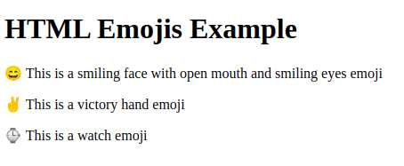

*HTML Emoji*

**Explanation:**

* In the above example we define the document type with <!DOCTYPE html>. Set charset with <meta charset=”UTF-8″>.
* Ensure proper display across devices with <meta name=”viewport” content=”width=device-width, initial-scale=1.0″>.
* ?: Smiling face with open mouth and smiling eyes.
* : Victory hand emoji.
* : Watch emoji.
* Emojis represented using Unicode values in HTML.

| **Char** | **Decimal reference** | **Hexadecimal reference** |
| --- | --- | --- |
| ? | 128516 | 1F604 |
|  | 9996 | 270C |
| ? | 128350 | 1F55E |

**2. HTML Emojis using Unicode hexadecimal reference**

HTML Emojis are displayed using Unicode hexadecimal references like &#x1F604;, allowing the inclusion of diverse symbols and icons in web content.

**Syntax:**

<p>&#xhexaDecimal;</p>

**Example 2:** In this example, we will represent &#128516, &#9996and &#128350 emoji in a webpage with hexadecimal(hex) reference.



1

<!DOCTYPE html>

2

<html lang="en">

3

​

4

<head>

5

<meta charset="UTF-8">

6

<title>HTML Emojis Example</title>

7

</head>

8

​

9

<body>

10

<h1>HTML Emojis Example using Unicode hexadecimal </h1>

11

<p>

12

&#x1F604; This is a smiling face with open mouth

13

and smiling eyes emoji

14

</p>

15

<p>&#x270C; This is a victory hand emoji</p>

16

<p>&#x231A; This is a watch emoji</p>

17

</body>

18

​

19

</html>

**Output:**

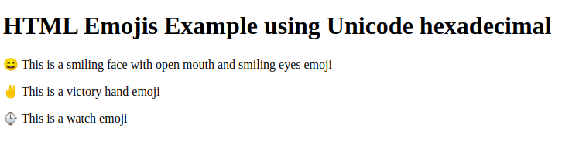

*HTML Emojis using Unicode hexadecimal*

**Explanation:**

* In the above example we defined with <!DOCTYPE html> and <html lang=”en”>.
* Unicode hexadecimal references used for emojis, like &#x1F604;, &#x270C;, and &#x231A;.
* Emojis represented by Unicode code points, enclosed in &#x and ;.
* Each emoji has a unique hexadecimal Unicode value.
* Emojis render according to their Unicode representations in modern web browsers.

**Note:** Since Emojis are characters, they can be copied, displayed and sized just like any other character in HTML.

**Example 3:** In this example, we will change the font size of the following emojis.



1

<!DOCTYPE html>

2

<html lang="en">

3

​

4

<head>

5

<meta charset="UTF-8">

6

<title>HTML Emojis Example</title>

7

<style>

8

.large {

9

font-size: 2em;

10

/* Increase font size */

11

}

12

</style>

13

</head>

14

​

15

<body>

16

<h1>HTML Emojis Example</h1>

17

<h3>Transport symbols</h3>

18

<p>

19

&#x1F682; Train &nbsp;&nbsp;

20

<span class="large">&#x1F6E5;</span> Tram

21

</p>

22

<h3>Office emojis</h3>

23

<p>

24

&#x1F3E2; Office Building &nbsp;&nbsp;

25

<span class="large">&#x1F4BC;</span> Laptop

26

</p>

27

<h3>People emojis</h3>

28

<p>

29

&#x1F468; Man &nbsp;&nbsp;

30

<span class="large">&#x1F469;</span> Woman

31

</p>

32

<h3>People emojis</h3>

33

<p>

34

&#x1F436; Dog &nbsp;&nbsp;

35

<span class="large">&#x1F981;</span> Lion

36

</p>

37

</body>

38

​

39

</html>

**Output:** The output contains the different sizes of emojis.

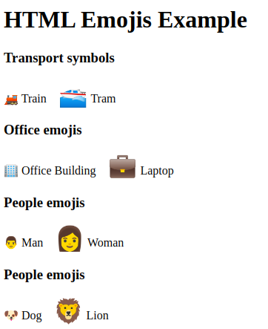

*Html Emoji Example*

**Explanation:**

* In the above example we defines various emojis using Unicode hexadecimal references.
* Emojis are categorised into transport symbols, office emojis, people emojis, and animal emojis.
* Each category includes two emojis, with every second emoji being larger in size.
* CSS is used to increase the font size of the larger emojis.
* The emojis are displayed alongside descriptive text to indicate their meaning or representation.